Community Council Meeting Agenda

Location: Library
October 24, 2022 at 3:40

- Open Meeting – Co-Chair Holly Watkins (Sara unable to attend)

- Rules of Order determined
    - Link to last years Rules of Order: Community Council - Eagle Bay Elementary School (davis.k12.ut.us)

- Data Comparison (3rd grade COVID year comparison)

- PBIS
    - Working on the first steps for specific expectations through JSSC
Example:
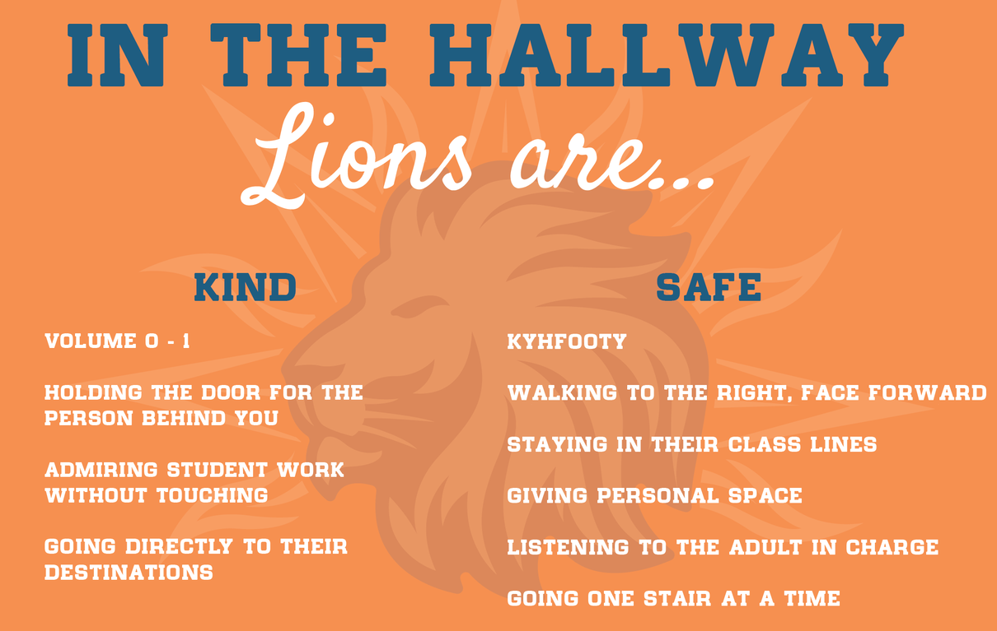
    - Steps for flow of consequences discussion
-Reminder/Reteach (3?)
-Think Time in another classroom (used in previous years, sent home for signature)

- Adjournment – Holly Watkins

